Medical Records

Aim: -
The aim of this experiment is to create a basic record to store
a patient’s information.

Research: -
Medical records (also called health records or clinical records)
are organized documents that contain a patient’s complete
medical history and health information.
They can be paper-based, digital (EHR/EMR), or a
combination.
A medical record usually includes:
- Personal information (name, age, contact)
- Past medical history
- Diagnoses and symptoms
- Lab test results
- X-rays, scans, and imaging reports
- Prescriptions and medications
- Treatment plans and progress notes
- Surgical notes
- Allergies and immunizations
- Doctor’s and nurse’s observations
- Discharge summaries
Thus, they serve as a timeline of a patient’s health.

References: -
1.https://v2020eresource.org/content/files/Medical_Records_Manual.pdf
2. https://www.ahima.org/academics/education-catalog/health-information-management-technology/

Analysis: -
Medical records are important for several reasons:
1. Continuity of Care
Doctors need patient history to make correct decisions.
Medical records ensure that every doctor involved in a
patient’s care knows:
- previous treatments
- medications already taken
- allergies
- ongoing conditions
This prevents mistakes and improves treatment accuracy.
2. Legal Evidence
Medical records are official documents.
They serve as legal evidence in case of:
- medical disputes
- insurance claims
- court cases
- medico-legal issues
They help prove what treatment was given and when.
3. Research and Public Health
Hospitals and health agencies analyse medical records to:
- study disease patterns
- track outbreaks
- evaluate treatment success
- plan healthcare policies

Ideate: -
In this code, we recreate string functions using user-defined
functions.
In this program the string functions recreated are: -
1. strlen function: -
For recreating the strlen function, a while loop is used containing 2 integers i and count, value of count is returned.
2. strcpy function: -
For recreating the strcpy function, we use a for loop and store values of the original string into the copied string.
3. strcmp function: -
For recreating the strcmp function, we use a while loop.
4. strcat function: -
For recreating the strcat function, we use 2 while loops for both the source and destination string.
Build: -
#include<stdio.h>
int Strlen(char str1[])
{
int i = 0;
int count = 0;
while(str1[i] != '\0')
{
i++;
count++;
}
return count;
}
int Strcpy(char str2[], char str1[])
{
int i;
for(i = 0; str1[i] != 0; i++)
{
str2[i] = str1[i];
}
str2[i] = '\0';
}
int Strcmp(char *str1, char *str3)
{
while(*str1 != '\0' && *str3 != '\0' && *str1 == *str3)
{
str1 ++;
str3 ++;
}
return (int)(unsigned char)*str1 - (int)(unsigned char)*str3;
}
char *Strcat(char *dest, const char *src) {
char *original_dest = dest;
while (*dest != '\0') {
dest++;
}
while (*src != '\0') {
*dest = *src;
dest++;
src++;
}
*dest = '\0';
return original_dest;
}
int main()
{
char name_i[50];
char name_d1[50] = "Albert";
char name_c[50];
char name_d2[50] = "Einstein";
printf("Enter name of patient: ");
scanf("%s", name_i);
int res = Strcmp(name_i,name_d1);
if(res == 0)
{
printf("Name found in Directory.\n");
int length = Strlen(name_i);
Strcpy(name_c,name_i);
Strcat(name_d1,name_d2);
printf("\n Patient Details \n");
printf("+-----------------------------------+\n");
printf("Name of patient: %s |\n", name_c);
printf("Length of first name: %d |\n", length);
printf("Email id: %s@hospital.com|\n", name_d1);
printf("+-----------------------------------+\n");
}
else
{
printf("Name not found in Directory.\nPlease try again.\n");
}
}

Testing: -
Case 1: -
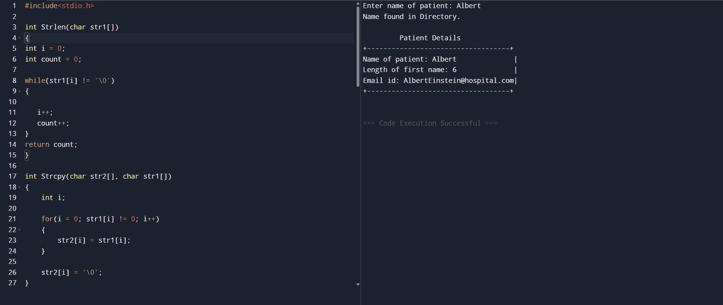
Case 2: -
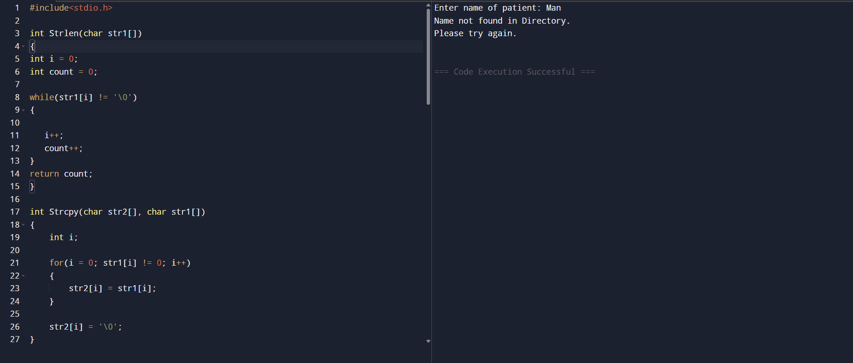

Implementation: -
https://github.com/Ravin-dev-129/Medical-Records

Conclusion: -
Thus, this experiment gives a basic code for storing a medical record of a patient using string functions.

